**PROJECT DEVELOPMENT PHASEPROJECTDEVELOPMENTDELIVERYOFSPRINT3**

**Project Name: IOT based safety gadget for child safety monitoring andnotification**

**Theproblemsintraditionalapproachesarelistedbelow.**

* Manualoperations.
* DelayedMessageService.
* NoTrackingfacility.

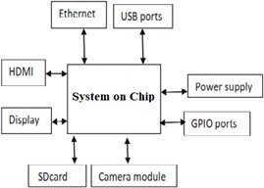

It was sold in as relatively easy feature enhancement requiring a small team sizeand limited time. It ended up ballooning in scope, people requirement and timetaken–andthe forecastdelivery datewaschanged multipletimes.

Thetworoot-causemetricareasincontrolofstakeholdersare:

* Changingscopeandrequirements;
* Anddelayedfeedbackandprojectinput

Thesevenroot-causemetricsareasincontrolofthe deliveryteamare:

* Peopleavailabilityandfocus;
* Teammakeupandstress;
* Backloghealthandestimationaccuracy;
* Dependabilityandsprintaccuracy;
* Deliveryprocessefficiency;
* Storymanagementandcomplexity;
* Anddefectgeneration andrework.